Final Workshop

Hey,
It's me again… Just a little instruction…

Setting up a server on AWS:
- Create a new EC2 server with a Linux distribution (e.g., Amazon Linux 2 or Ubuntu).
- Open the required ports (e.g., SSH, HTTP).
Connecting to the server:
- Use SSH to connect to the server.
Basic Commands Creating files and directories:
- Create a directory named [yourname]project.
- Create a directory named backup.
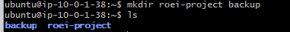
- In [yourname]project directory, create a text file named info.txt and add the words "Hello, World!" to it.
User and Permissions Management:
- Create a new user named student.
- Set a password for the user.
- Add the user to the sudo or wheel group.
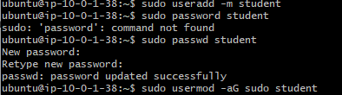
File Permissions:

- Change the permissions of the file info.txt so that only the owner can read and write to it.
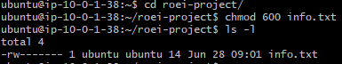
Scripts Creating a simple script:
- Create a script named backup.sh in the [yourname]project directory, that backs up the [yourname]project the to backup directory.
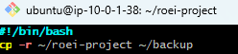
Using the vi editor:
- Open the file info.txt with the vi editor and update its content.
- Add anything you like to the file.
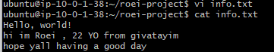
Installing NGINX:
- Install NGINX and start the service
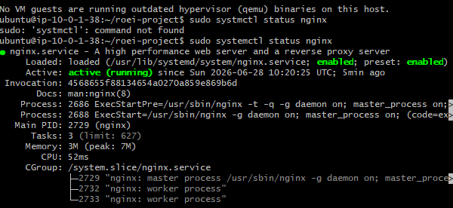

Ensure NGINX is running and access the basic HTML page in the browser.
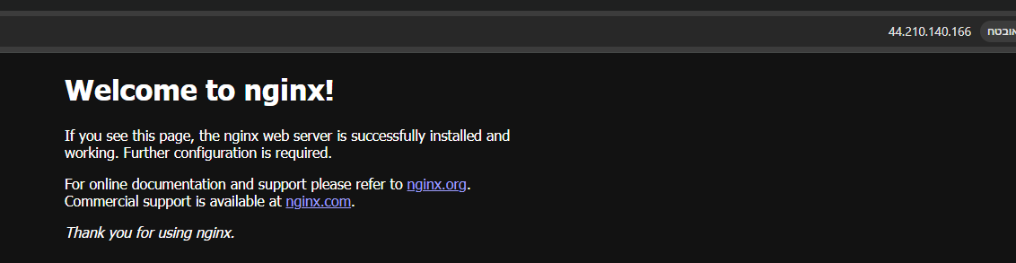
Check the system log.
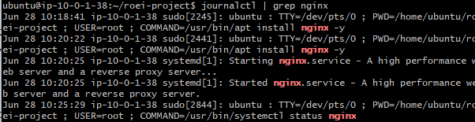
Process Management:
- Display all the processes on the system and kill a specific process.
ps aux
kill(PID של מה שאנחנו רוצים להפסיק)
Managing Storage Devices:
- Display disk usage.
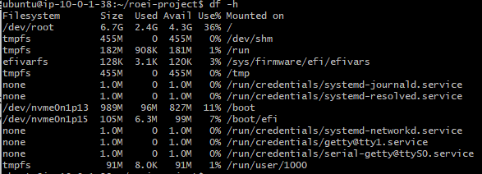

Final Test Write 2 scripts that performs the following actions:

script 1:
- Checks if there is free space on the disk.
- Backs up the /etc directory to the backup directory.
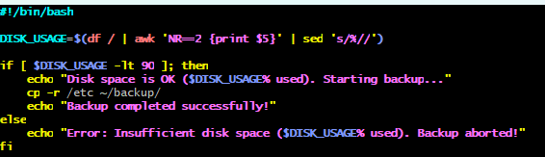
script 2:
- Checks the disk health status and stores the result.
- Collects system information, including uptime, load average, and memory usage.
- Displays the five processes consuming the most memory.
- Writes the collected information to the system_report.txt file.

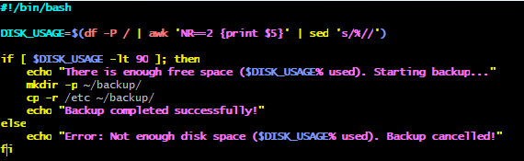

- Now use linux command to move the files to your local host out from the server via ssh
- written report && scripts Send the files via email to the instructor mail (name@nitzanim.tech)

Good luck!
Don't forget he is about to be here in an 2 hours.
Jacki
Head of Linux Team

